Order Of Service

Singing: Psalm 8—CW page 67

Reading: Psalm 17

Opening Hymn: CW 260

Reading: Revelation 1:9-20

Request Hymn: CW Supplement 752

Reading: John 3:16-21

Sermon Hymn: CW 363

Sermon Text: Song Of Solomon 4:6

Until The Day Breaks

Prayer

The Apostles’ Creed, TLH page 12

Holy Communion

The Lord's Prayer

The Blessing

Closing Hymn: CW 245

* * * * * * * * * * *

Bible Study: Lambs: I Kings 2:1-4; Stay Close To God
Sheep: Proverbs 10:27-28
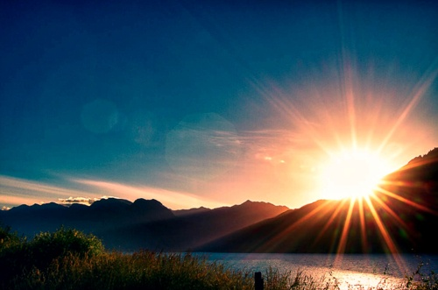

Until The Day Breaks

Water
Of
Life
21 August 2016

W A T E R O F L I F E

Independent Christian Church—Conservative Lutheran Doctrine

Worship Service: 9:30 a.m. Bible Study: 10:45 a.m.

Larry Cooper, Pastor E-Mail address:
111 N. Ridge Road lcooper@wateroflife.cc
Coon Valley, WI 54623 Web Site:
Phone: (608) 452-2105 www.wateroflife.cc

* * * * * * * * * * * * * * * * * * * * * * * * * * *

Sermon Text: Song Of Solomon 4:6

Until The Day Breaks

* * * * * * * * * * * * * * * * * * * * * * * * * * *

Song of Solomon 4:6 Until the day break, and the shadows flee away, I will get me to the mountain of myrrh, and to the hill of frankincense.
**********

In Song Of Solomon 2:17 the Bride had said to her Bridegroom: “Until the day break, and the shadows flee away, turn, my beloved, and be thou like a roe or a young hart upon the mountains of Bether.”

Here in Song Of Solomon 4:6 we seem to have the Bridegroom’s answer to the prayer of his Bride.
Here, from the pen of another, who is acquainted with the geography of the Holy Land, we have a description of what the breaking of day is like:

“In those hot countries the dawn of day is attended with a fine, refreshing breeze, much more grateful and desirable than the light itself, beautifully expressed by the words ‘the day breathes.’

“The excessive heat on the coast, and in many places of the Holy Land, is very much lessened by a sea-breeze, which constantly blows every morning, and by its coolness renders the heats of summer very supportable. Every morning about sunrise, a fresh gale of wind blew from the sea across the land, which from its wholesomeness in clearing the infected air, is always called “The Doctor.”

“At the approach of morning, the stir of life that seemed, like leaven, to ferment the surface of the world around, was very striking; first, the partridge’s call joined chorus with the nightingale, and soon after their dusky forms were seen darting through the bushes, and then bird after bird joined the chorus; the lizards began to glance upon the rocks, the insects on the ground and in the air; the jerboa peeping from its burrow, fish glancing in the stream, hares bounding over the dewy grass, and—as more light came—the airy form of the gazelle could be seen on almost every neighboring hill.

“Then came sunrise, first flushing the light clouds , then flashing over the Arabian mountains, and pouring down into the rich valley of the Jordan: the Dead Sea itself seemed to come to life under that blessed spell, and shone like molten gold among its purple hills.”

Another page from The Volume of Nature.

